**STEMMNet Assembly Guide**

The following document can be used to assemble STEMMNet soil and temperature monitoring stations. This guide is a living document, and may be modified as improvements are made. Follow the step-by-step instructions to build your very own low cost STEMMNet sensor. For more information about STEMMNet, or the data that is retrieved, contact Lee Ellenburg or Michael Solomon at the University of Alabama in Huntsville.

Step 1: Gather the necessary components from the Parts List document.

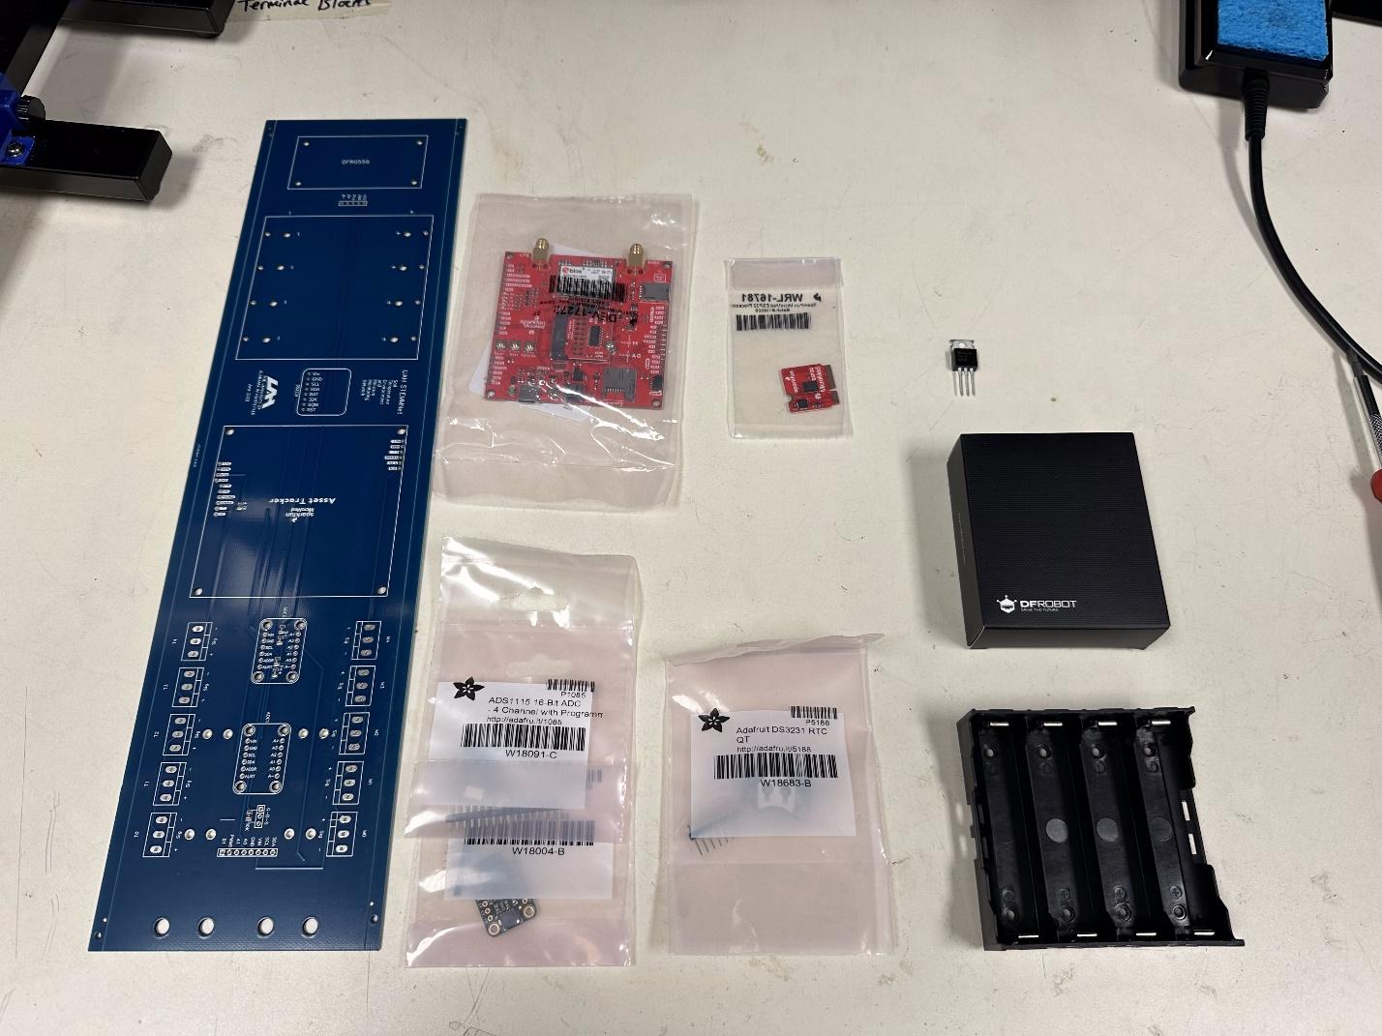

Step 2: Remove the solar controller from the DFRobot box, including the hardware and the cooling fin.

Step 3: Mount the cooling fin on the bottom of the solar controller in the designated area with the included double-sided adhesive.

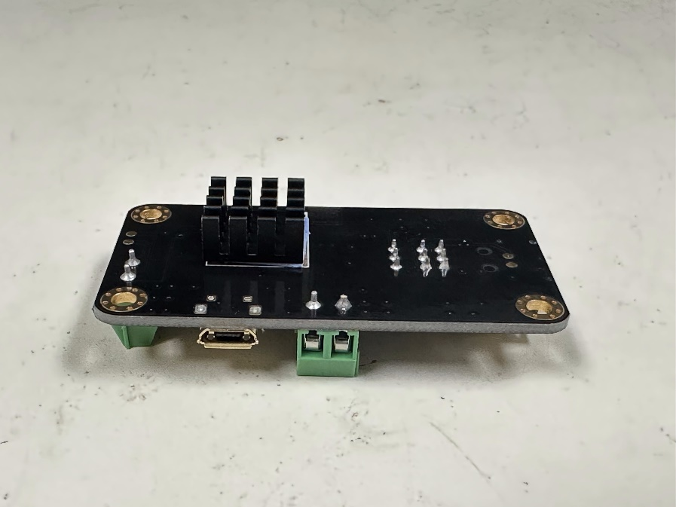

Step 4: Mount the standoffs for the solar controller on the top of the PCB in the location designated as DFR0559.

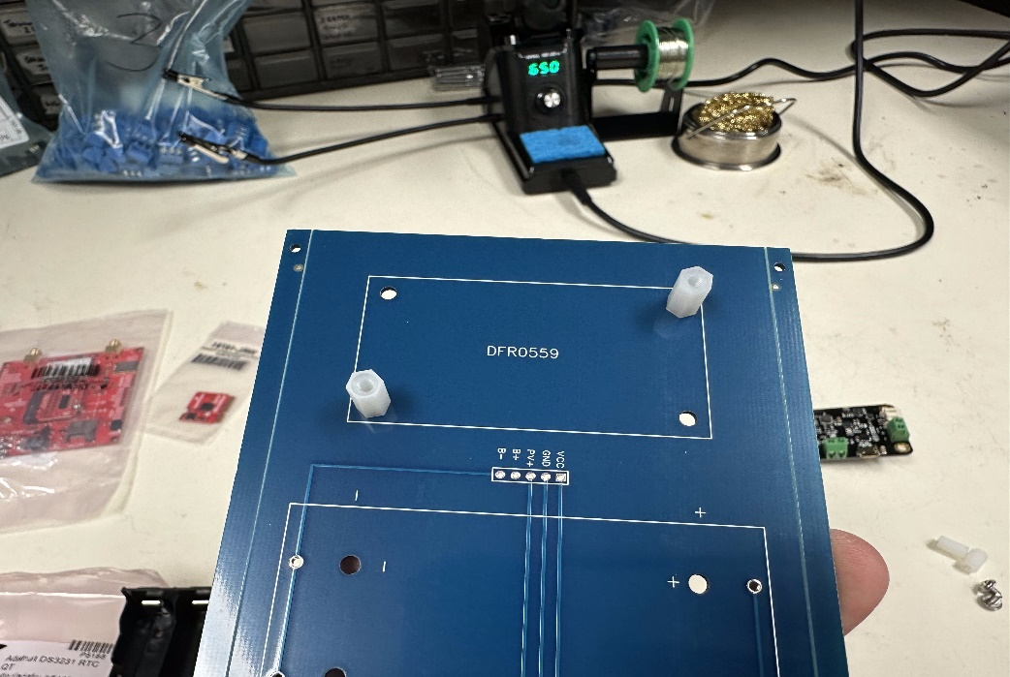

Step 5: Get one red and one black jumper wire. Cut the wires in half and strip the insulation off about ¼ inch.

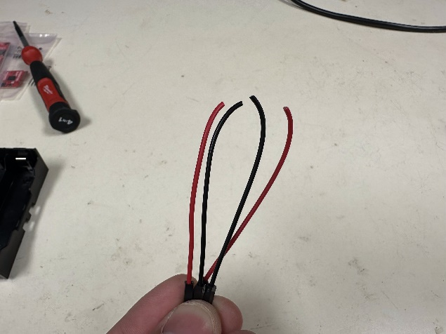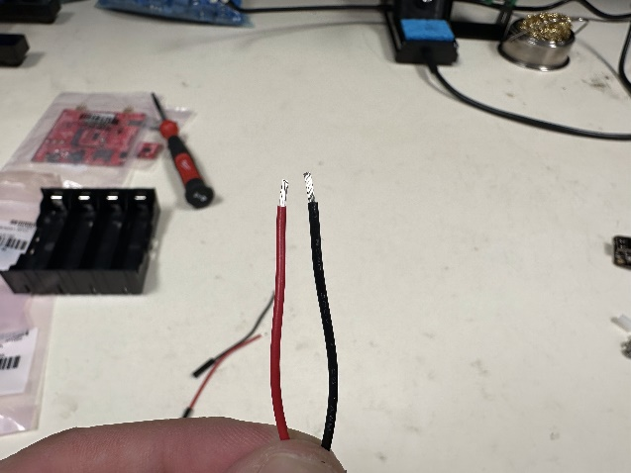

Step 6: Solder the red wire to the positive “solar in” post on the bottom of the solar controller (cooling fin side).

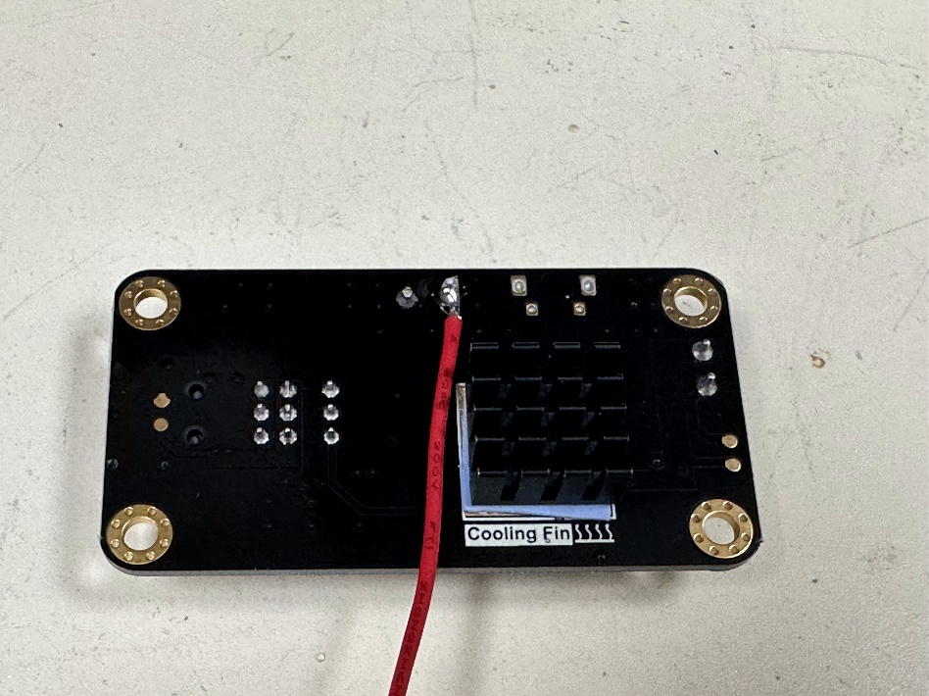

Step 7: Set aside the solar controller and remaining jumper wires for later.

Step 8: Snap off 5 header pins from a strip.

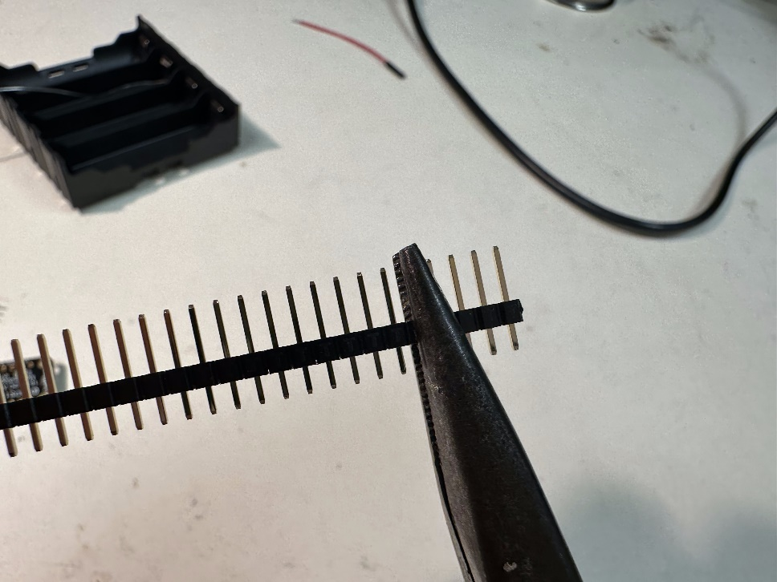

Step 9: Solder the pins into the 5 open points next to the solar controller.

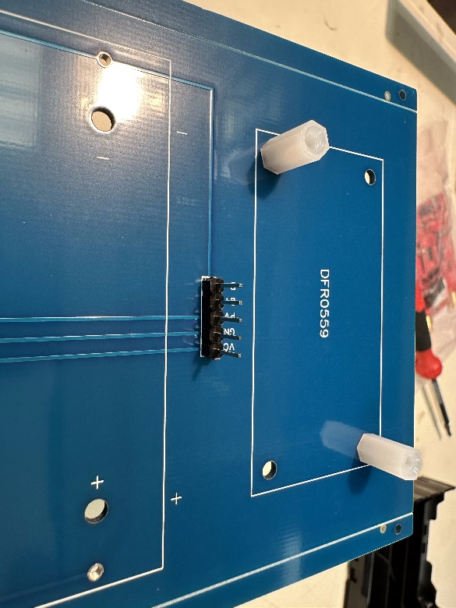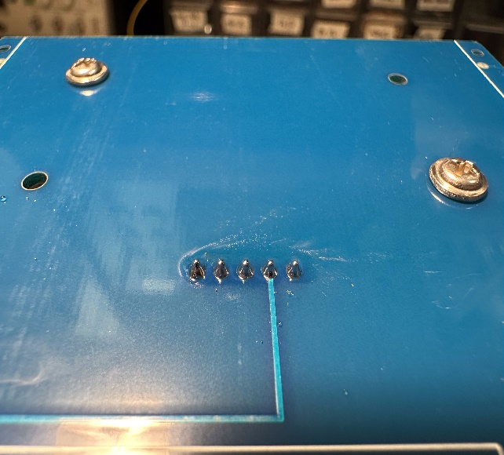

Step 10: Mount the battery pack onto the PCB. (Make sure polarity of the plastic matches the polarity on the PCB. Solder the battery pack connections on the bottom side of the PCB.

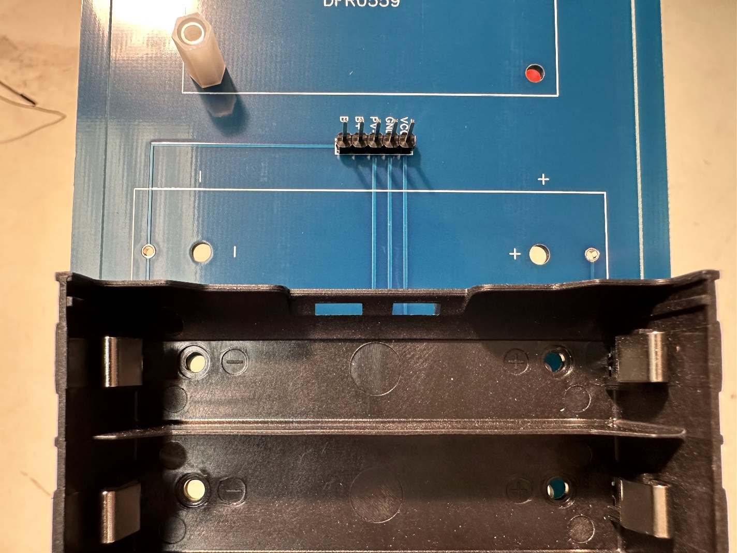

Step 11: Attach the jumper wires to the 5 pins soldered in step 9.

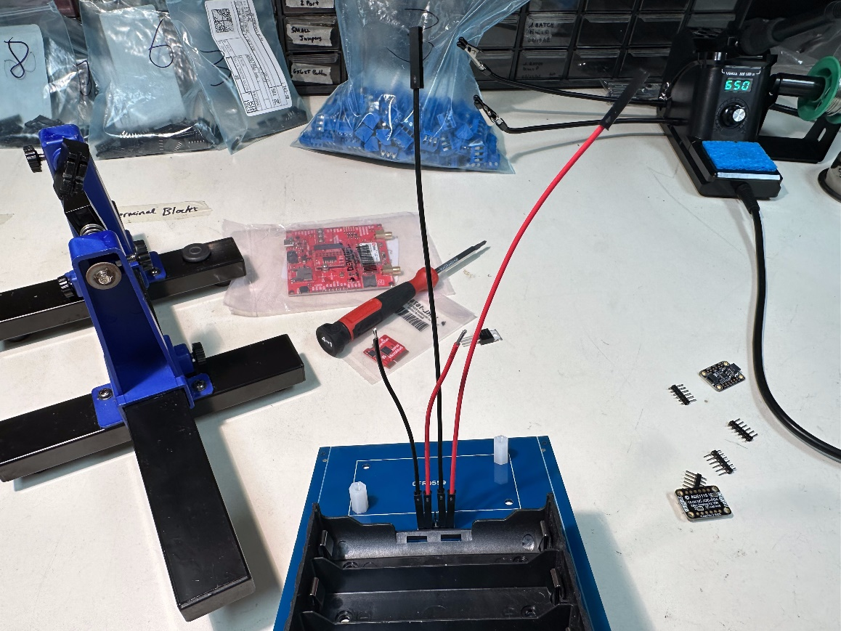

Step 12: Attach the solar controller positive wire (soldered in step 6) to the middle pin.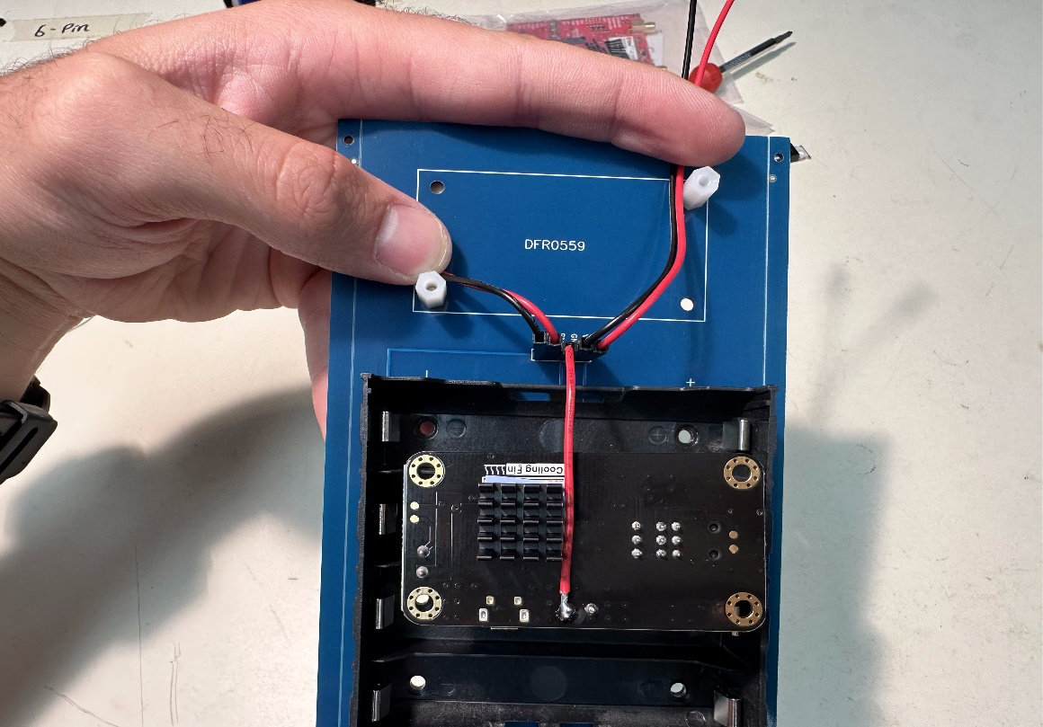

Step 13. Holding the wires down (Step 12 Image) mount the solar controller on the standoffs using two of the screws from the included hardware.

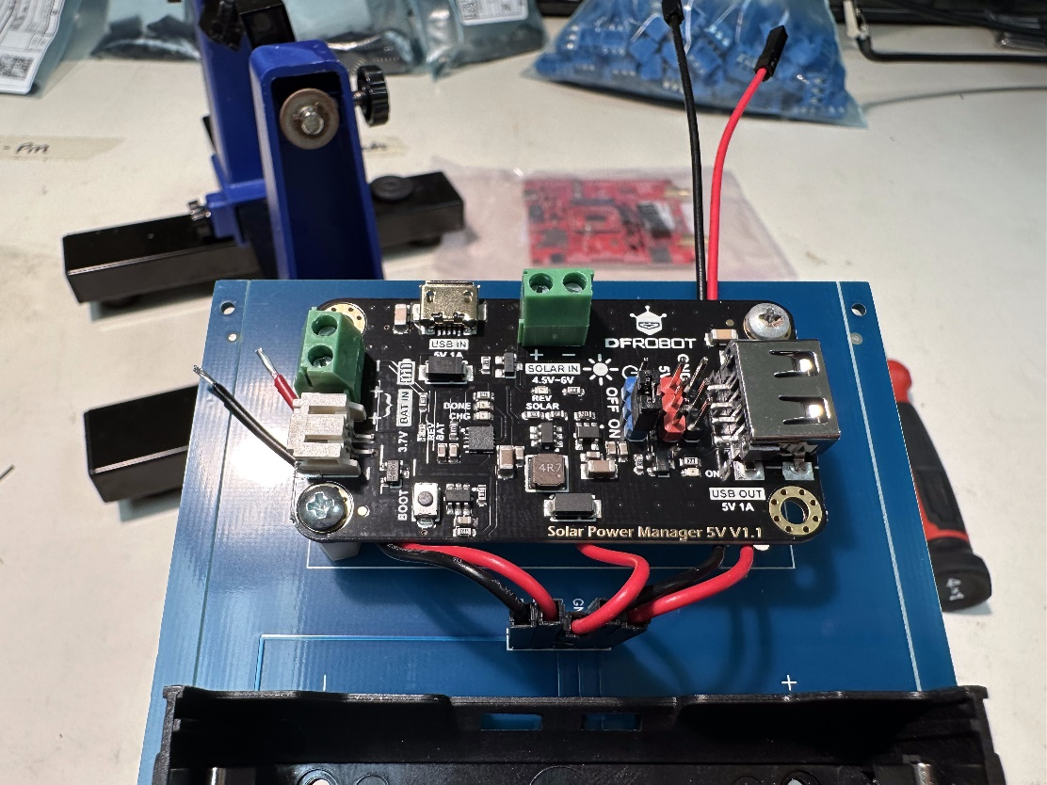

Step 14: Attach the two wires (red and black) on the right side in Step 13 to the pins shown below.

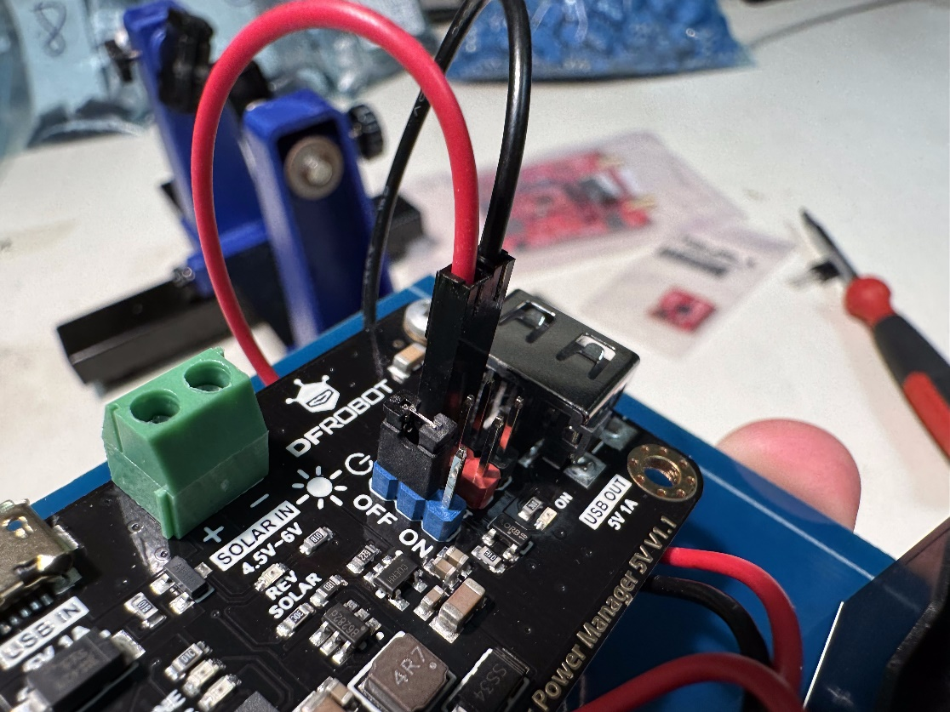

Step 15: Unscrew the set screws shown below, and then mount the left two (black and red) wires from step 13 into the connectors. Once the wires are in place, tighten the set screws.

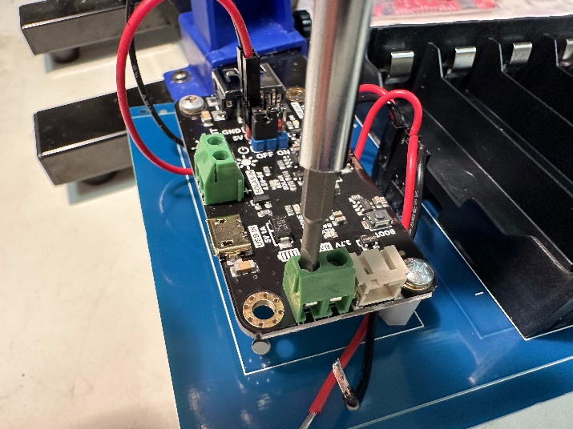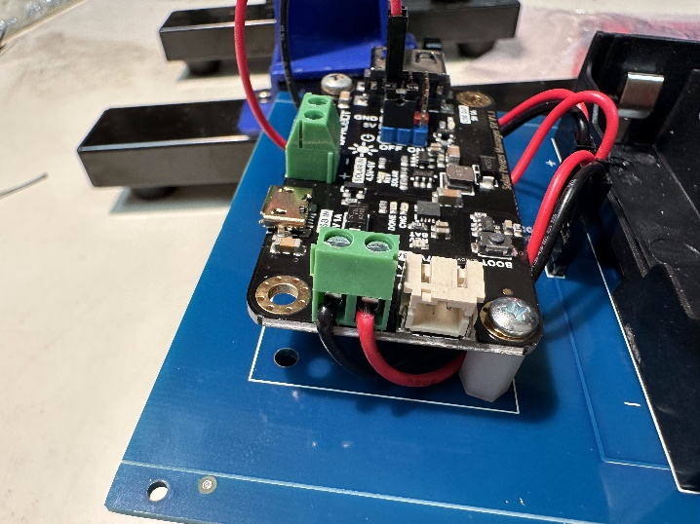

Step 16: Gather all the header sockets needed for the STEMMNet.

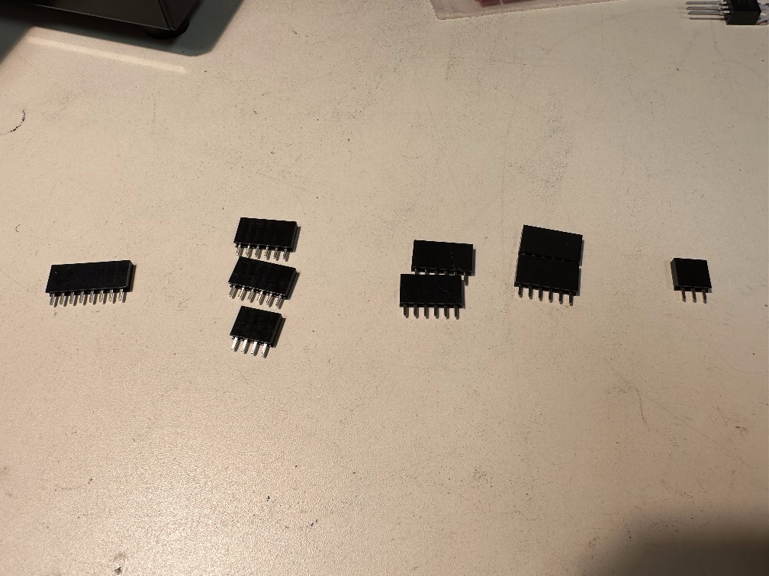

Step 17: Mount the 8-pin header socket in the spot shown below. Solder the block in place on the bottom of the PCB.

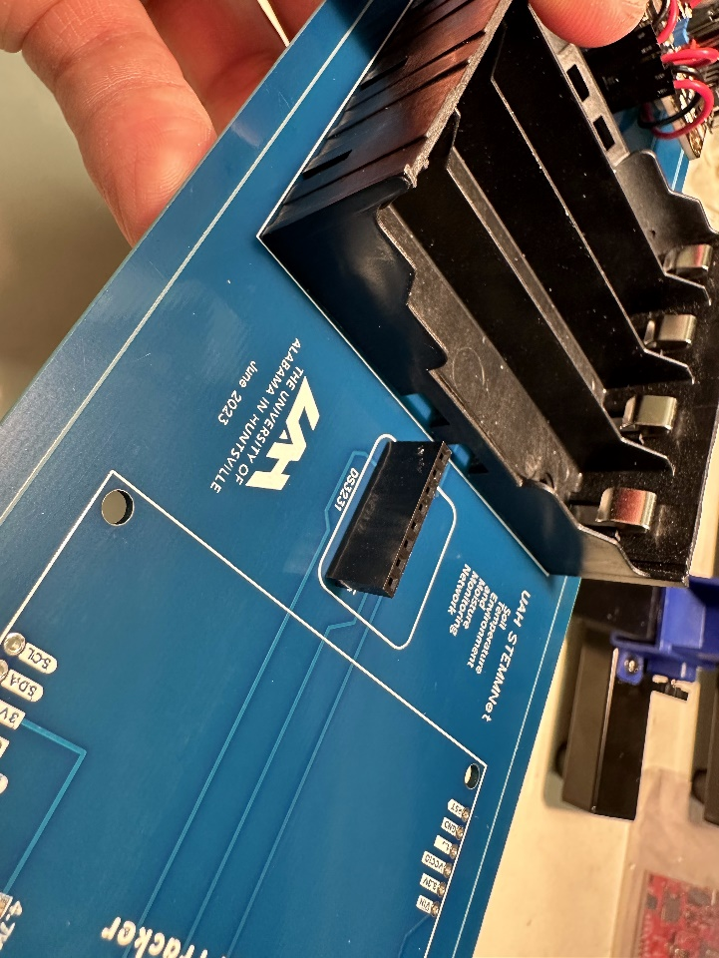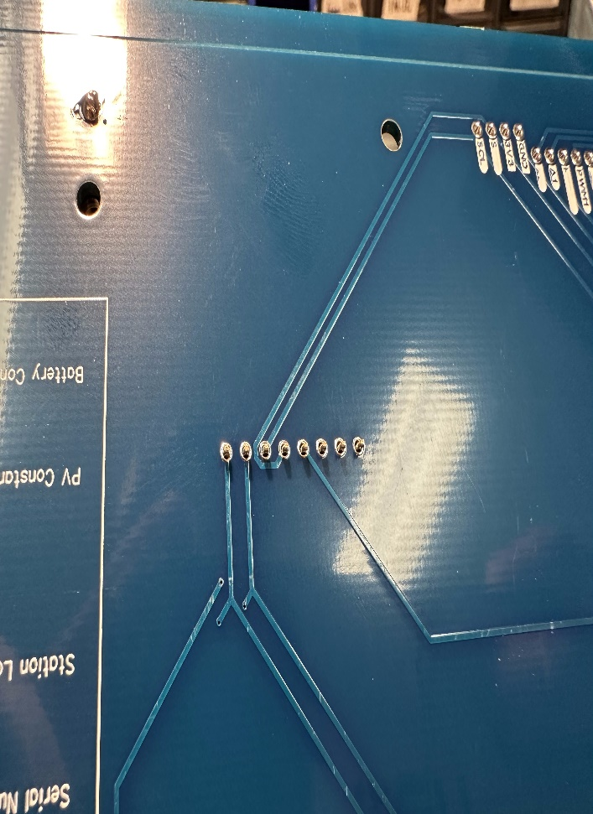

Step 18: Place and solder the asset tracker header sockets in their correct locations, shown below. When soldering, ensure the headers sockets are mounted as straight as possible.

Step 19: Solder the header pins to the asset tracker (shown in the images below).

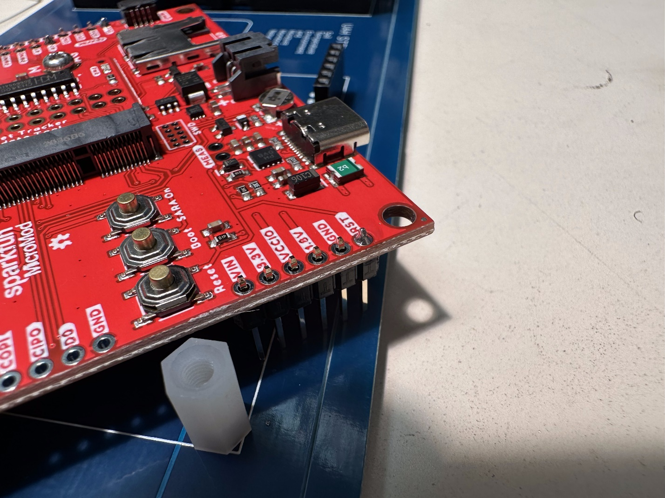

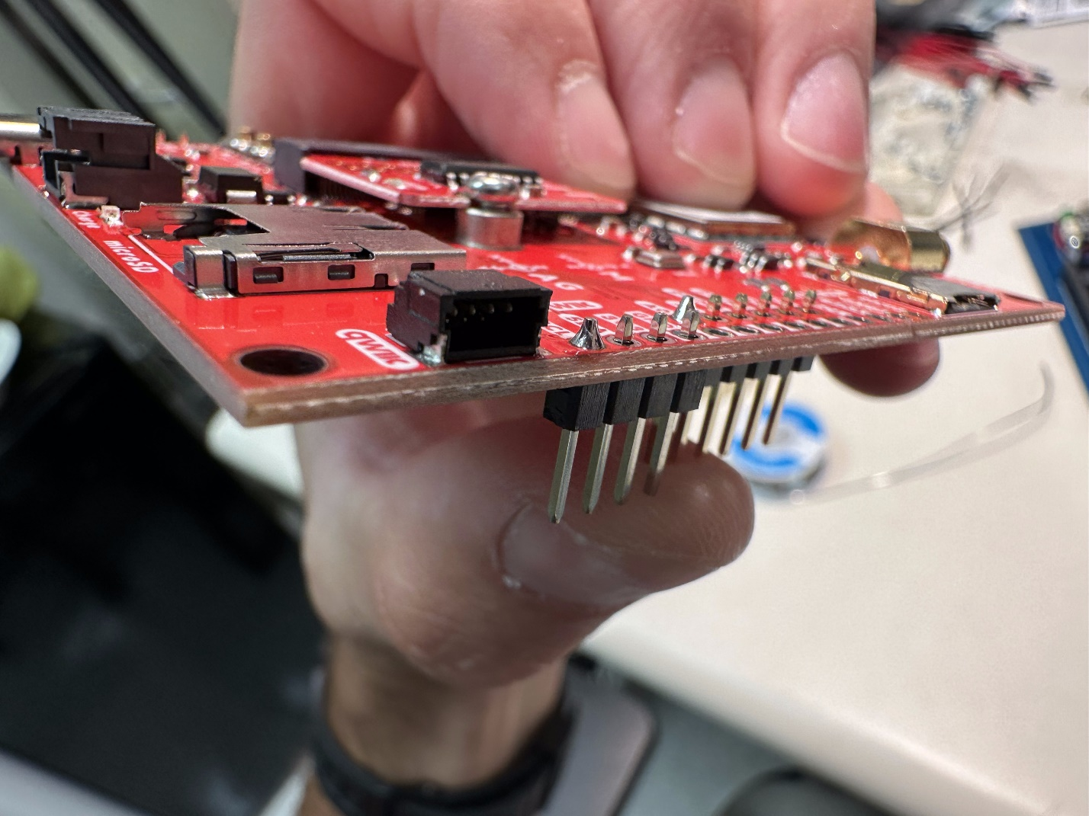

Step 20: Mount the asset tracker onto the header sockets, and the two standoffs shown below.

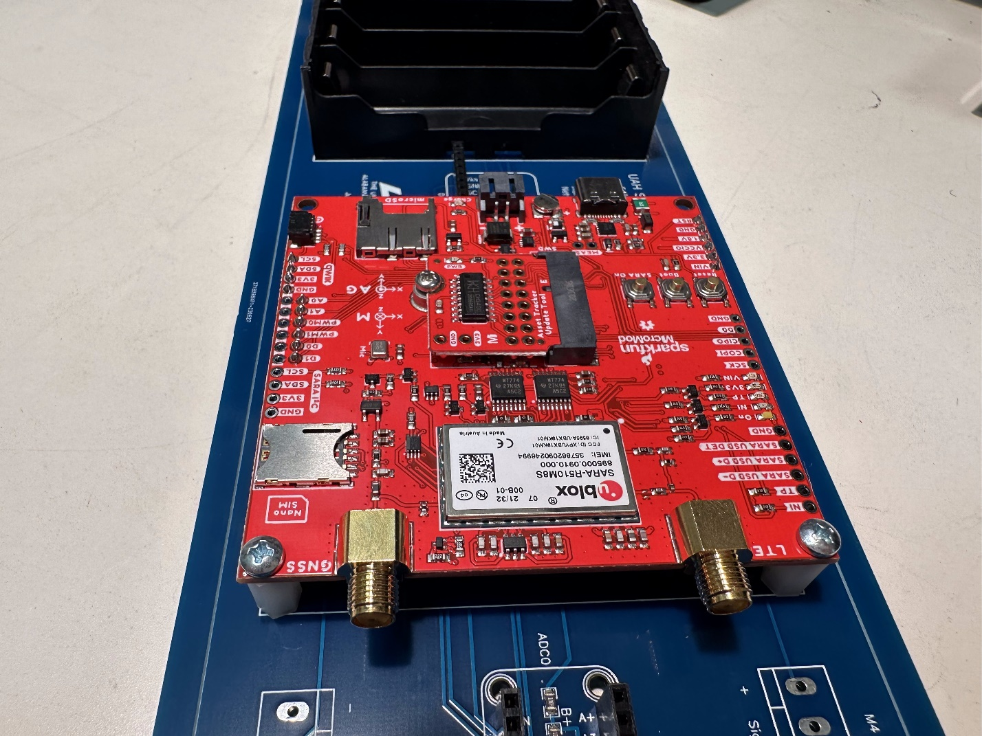

Step 21: Remove the chip on the asset tracker, and replace it with the ESP32 processor. 

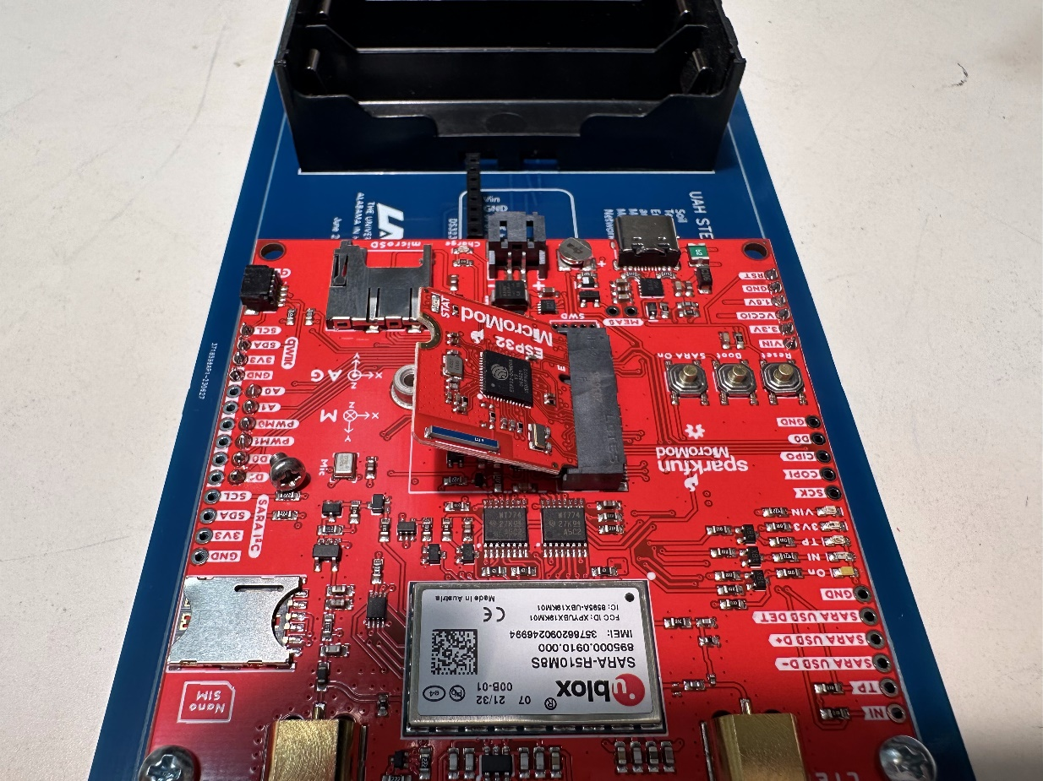

Ensure that the ESP32 is mounted correctly.

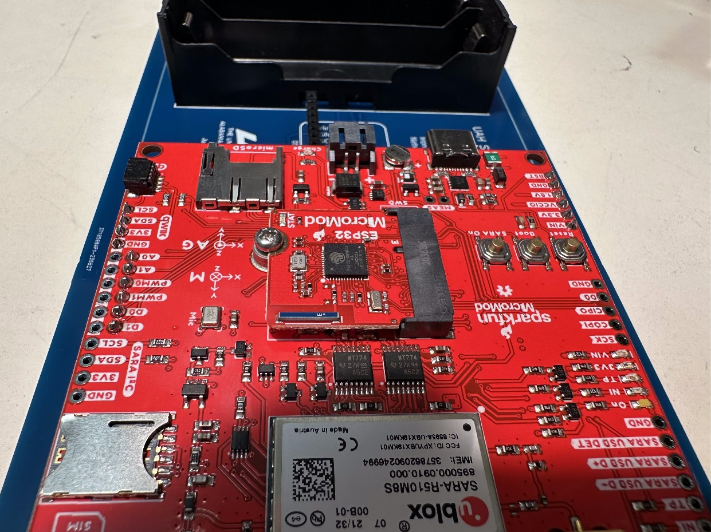

Step 22: Install the SIM card and the SD card in the correct slots. 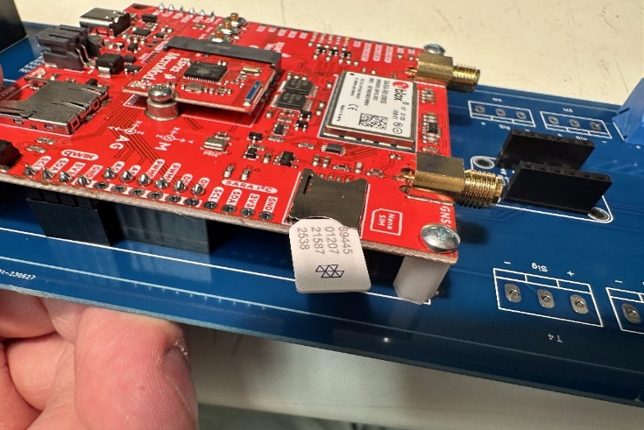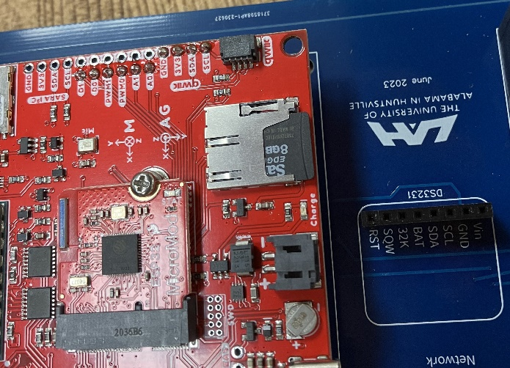

Step 23: Mount and solder the header sockets for the two analog to digital converters (ADCs).

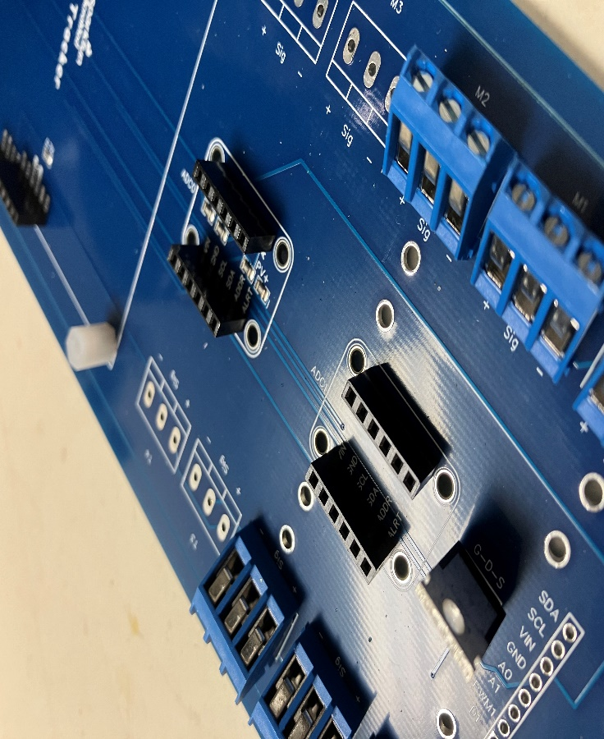

Step24: Solder the header pins onto the two ADCs.

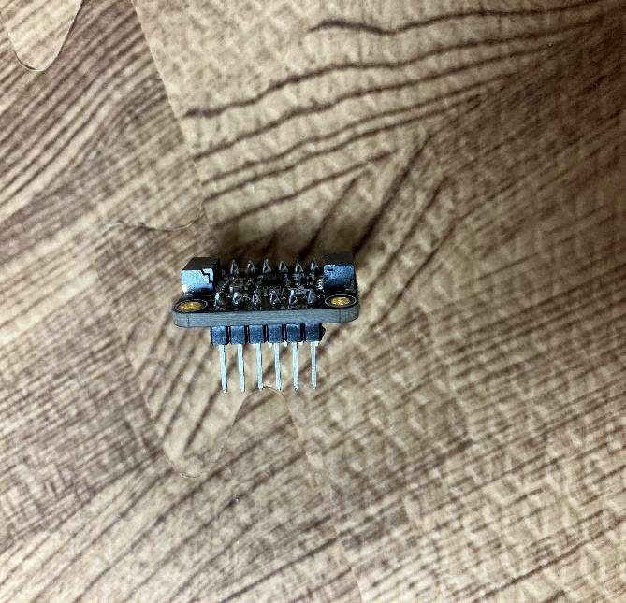

Step 25: Solder the connection pad (Shown Below) on the bottom of one of the ADCs.

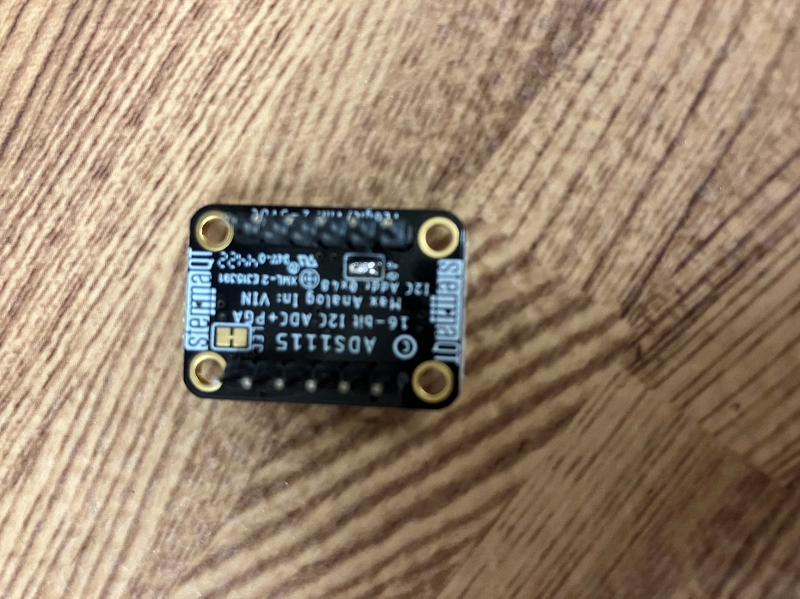

Step 26: Mount the two ADCs on the header sockets, mount the one that was soldered farthest away from the asset tracker.

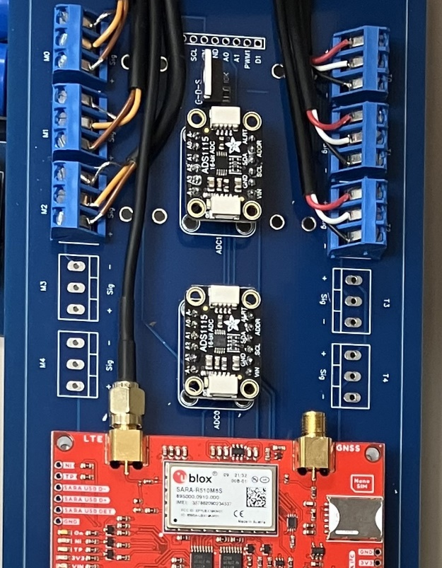

Step 27: Mount and solder the 3-pin terminal blocks as shown below. (This may vary depending on the number of sensors desired.)

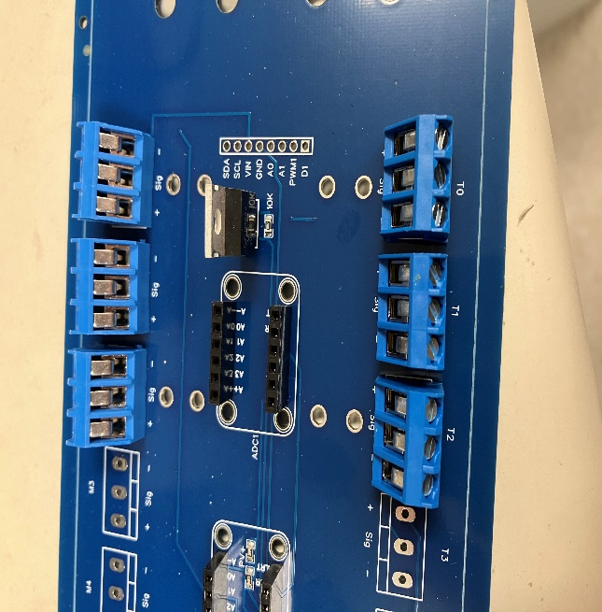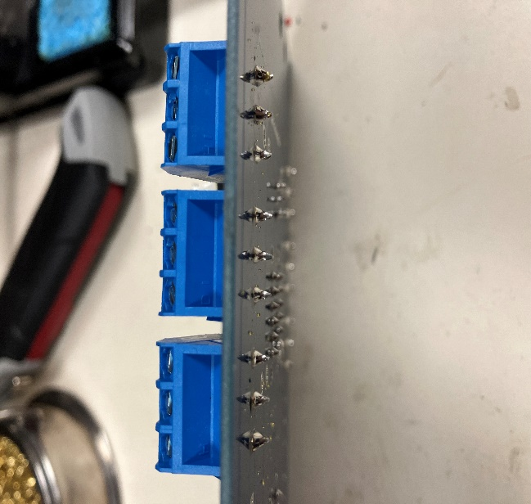

Step 28: Mount the MOSFET into the pins shown below. **Make sure the MOSFET is mounted in the same orientation as shown below**.

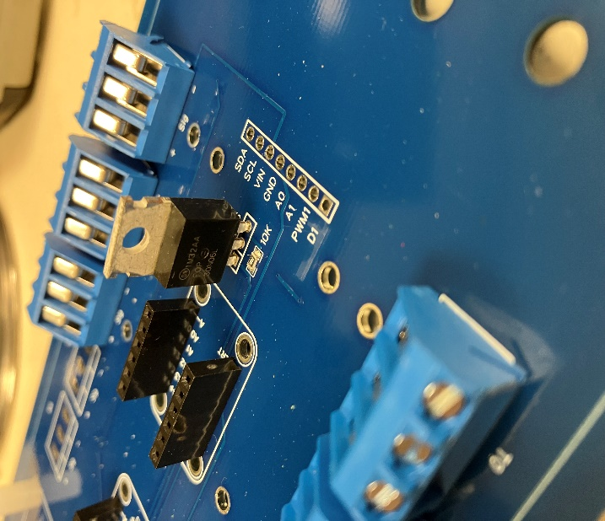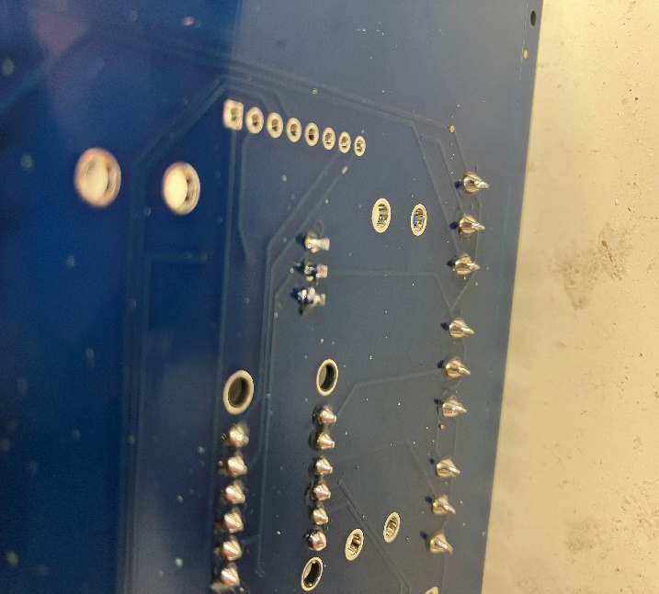

Step 29: Using a QWIC connect cable, install a diode by cutting the red wire and soldering a diode to allow power flow from the asset tracker to the clock. Reference the photos below. When done, tape the wire to avoid possible shorting.

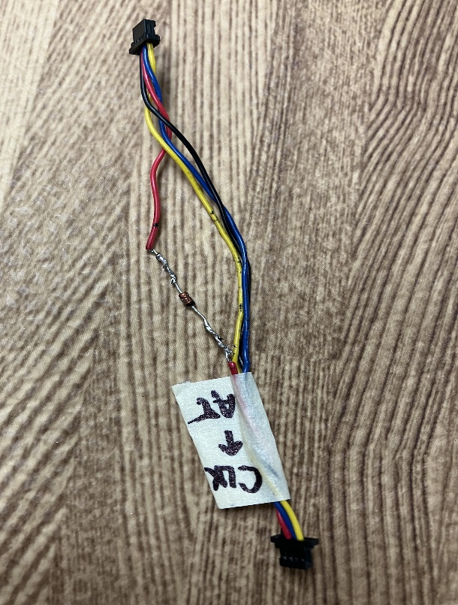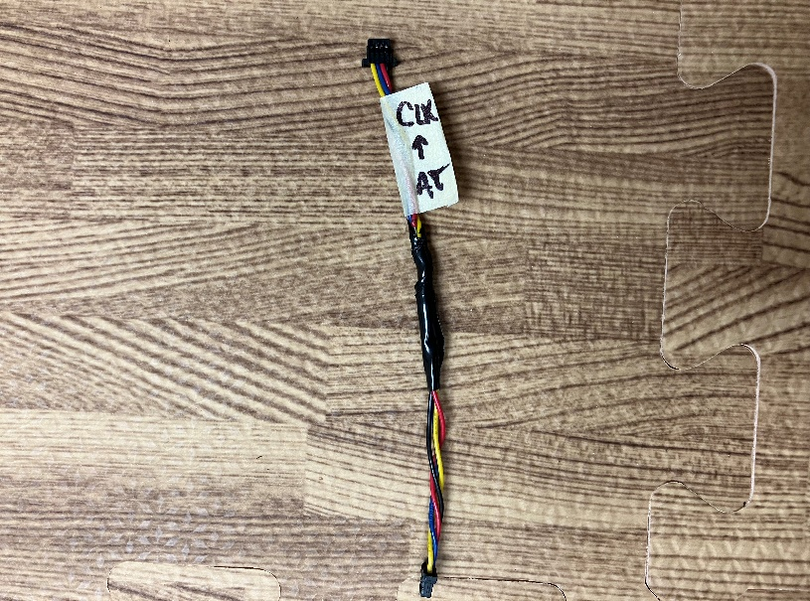

Step 30: Using a pair of snippers or wire cutters, cut the header pin for the “Vin” pin on the RTC.

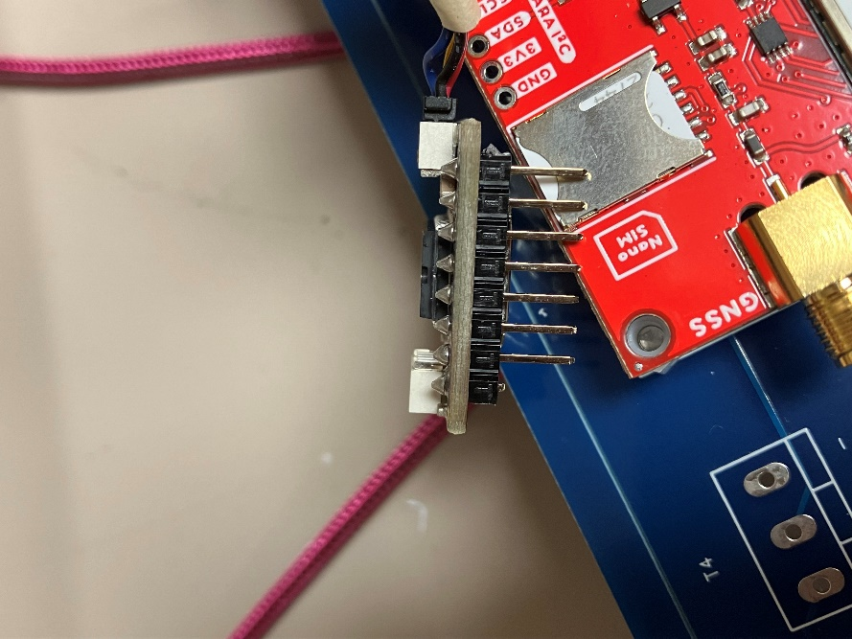

Step 31: Attach the QWIC cable to the Asset tracker and the clock as shown below. Mount the clock onto the header socket.

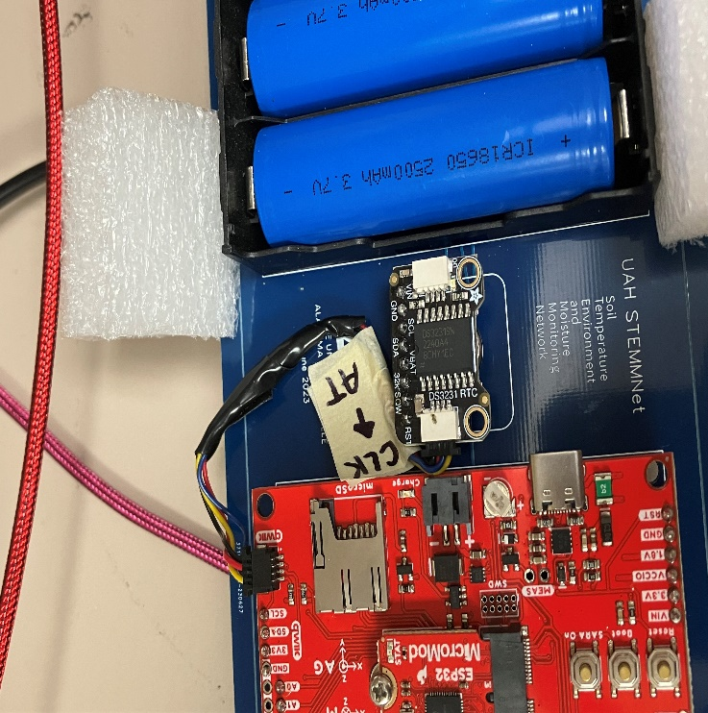

**EXTRA INFORMATION:**

We bend the battery connectors out slightly to better hold the batteries in place.

To accurately monitor the battery voltages, a battery constant must be assigned to each station. We found that 2.11 is close to the average value.

Currently we use a QWIC cable with a diode soldered in-line to power the RTC clock and prevent the button battery from being drained by the STEMMNet. Eventually, this will be replaced by a built-in diode within the PCB.

We currently deploy three temperature and three moisture sensors, which means six 3-pin terminal blocks are mounted on the boards. This also leaves room for two more of each sensor to be installed.

There is a text box on the back of the PCB designed for the ID and Other information for the STEMMNet.